**Southern University of Science and Technology**

**Doctoral Dissertation Proposal**

**Title：**

**Department**

**Discipline**

**Supervisor**

**Student Name**

**Student Number**

**Date of Proposal Report**

**Graduate school**

**TABLE OF CONTENTS**

CHAPTER 1 TITLE 1

1.1 Title 1

1.2 Tables, Figures and Equations 1

1.2.1 Tables 1

1.2.2 Figures 2

1.2.3 Equations 2

CHAPTER 2 TITLE 3

2.1 Title 3

2.1.1 Title 3

CHAPTER 3 TITLE 5

3.1 Title 5

3.1.1 Title 5

CHAPTER 4 TITLE 6

4.1 Title 6

4.1.1 Title 6

CHAPTER 5 TITLE 7

5.1 Title 7

5.1.1 Title 7

CHAPTER 6 TITLE 8

6.1 Title 8

6.1.1 Title 8

REFERENCES 10

# TITLE

## Title

Cells function is mainly determined by gene expression which is precisely controlled at space and time for every step, transcription, RNA 5’ capping, splicing, RNA polyadenylation, and translation.……

## Tables, Figures and Equations

### Tables

Fonts and point sizes for the thesis are summarized in Table 1-1.

Table 1-1 Typeface and spacing of a thesis

|  |  |  |  |  |  |
| --- | --- | --- | --- | --- | --- |
| Contents | Fonts and point sizes | | Line Spacing | Paragraph Spacing | |
| English | Chinese | Before | After |
| Level 1 headings | Arial 16 pt Bold | 黑体 16 pt Bold | 20 pt | 24 pt | 18 pt |
| Level 2 headings | Arial 14 pt Bold | 黑体 14 pt Bold | 20 pt | 24 pt | 6 pt |
| Level 3 headings | Arial 13 pt Bold | 黑体 13 pt Bold | 20 pt | 12 pt | 6 pt |
| Level 4 headings | Arial 12 pt Bold | 黑体 12 pt Bold | 20 pt | 12 pt | 6 pt |
| Table headings | Times New Roman 11 pt | | Single-spaced | 12 pt | 6 pt |
| Text in tables | Times New Roman 11 pt | | Single-spaced | 3 pt | 3 pt |
| Figure captions | Times New Roman 11 pt | | Single-spaced | 6 pt | 12 pt |
| Text in figures | Times New Roman 9-10.5 pt | | / | / | / |
| Equations | Xits Math 12 pt or  Cambria Math 12 pt or  Times New Roman 12 pt | | Single-spaced | 6 pt | 6 pt |
| Notes for tables/figures | Times New Roman 10.5 pt | | Single-spaced | 6 pt | 12 pt |
| Text of references | Times New Roman 10.5 pt | | 16 pt | 3 pt | 0 pt |
|  |  | | (Continued) | | |

Table 1-1 (Continued) Typeface and spacing of a thesis

|  |  |  |  |  |  |
| --- | --- | --- | --- | --- | --- |
| Contents | Fonts and point sizes | | Line Spacing | Paragraph Spacing | |
| English | Chinese | Before | After |
| Page headers/numbers | Times New Roman 10.5 pt | 宋体 10.5 pt | Single-spaced | 0 pt | 0 pt |
| Text (format not specifically indicated) | Times New Roman 12 pt | 宋体 12 pt | 20 pt | 0 pt | 0 pt |

### Figures

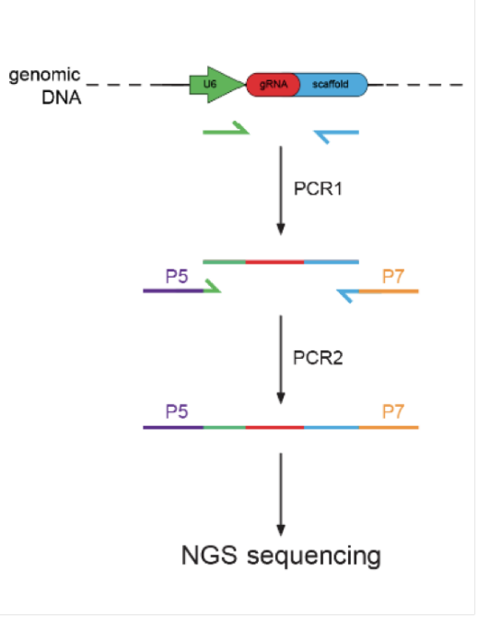……Procedure can be seen in Figure 1-1.

Figure 1‑ Construction of CRISPR screen sequencing library

Raw data in fast q format was processed with MAGeCK and visualized with VISPR. Prominent genes were filtered out based on the enrichment level in both control and experimental groups.

### Equations

Main text……Equation (1-1) is……

|  |  |
| --- | --- |
| $$f\left(x\right)=a_{0}+\sum_{n=1}^{∞}{\left(a_{n}\cos{\frac{nπx}{L}}+b_{n}\sin{\frac{nπx}{L}}\right)}$$ | (1-1) |

# TITLE

## Title

Main text …… Figure 2-1 illustrates……

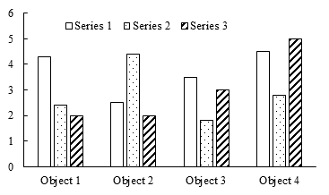

Figure 2-1 Caption

### Title

Main text……Equation (2-1) is……

|  |  |
| --- | --- |
| $$f\left(x\right)=a_{0}+\sum_{n=1}^{∞}{\left(a_{n}\cos{\frac{nπx}{L}}+b_{n}\sin{\frac{nπx}{L}}\right)}$$ | (2-1) |

……

Main text …… Table 2-1 shows……

Table 2- Title

|  |  |  |  |
| --- | --- | --- | --- |
| Header 1 | Header 2 | Header 3 | Header 4 |
| Row 1 |  |  |  |
| Row 2 |  |  |  |
| Row 3 |  |  |  |
| Row 4 |  |  |  |
| Row 5 |  |  |  |
| Row 6 |  |  |  |
|  |  |  | (Continued) |

Table 2-1 (Continued) Title

|  |  |  |  |
| --- | --- | --- | --- |
| Header 1 | Header 2 | Header 3 | Header 4 |
| Row 7 |  |  |  |
| Row 8 |  |  |  |
| Row 9 |  |  |  |
| Row 10 |  |  |  |
| Row 11 |  |  |  |

# TITLE

## Title

Main text

### Title

Main text

Main text……Equation (3-1) is……

|  |  |
| --- | --- |
| $$f\left(x\right)=a_{0}+\sum_{n=1}^{∞}{\left(a_{n}\cos{\frac{nπx}{L}}+b_{n}\sin{\frac{nπx}{L}}\right)}$$ | (3-1) |

# TITLE

## Title

Main text

### Title

Main text

Main text……Equation (4-1) is……

|  |  |
| --- | --- |
| $$f\left(x\right)=a_{0}+\sum_{n=1}^{∞}{\left(a_{n}\cos{\frac{nπx}{L}}+b_{n}\sin{\frac{nπx}{L}}\right)}$$ | (4-1) |

# TITLE

## Title

Main text

### Title

Main text

Main text……Equation (5-1) is……

|  |  |
| --- | --- |
| $$f\left(x\right)=a_{0}+\sum_{n=1}^{∞}{\left(a_{n}\cos{\frac{nπx}{L}}+b_{n}\sin{\frac{nπx}{L}}\right)}$$ | (5-1) |

# TITLE

## Title

Main text

### Title

Main text

Main text……Equation (6-1) is……

|  |  |
| --- | --- |
| $$f\left(x\right)=a_{0}+\sum_{n=1}^{∞}{\left(a_{n}\cos{\frac{nπx}{L}}+b_{n}\sin{\frac{nπx}{L}}\right)}$$ | (6-1) |

# REFERENCES

1. LIN S D. Water and wastewater calculations manual[M]. New York: McGraw-Hill, 2001.
2. GAO H, GALLAGHER K P. World needs stronger financial safety net[N/OL]. China Daily,2020-11-19[2020-11-20].

http://epaper.chinadaily.com.cn/a/202011/19/WS5fb5a952a31099a234351e21.html.

1. JHA M, GASSMAN P W, SECCHI S, et al. Effect of watershed subdivision on SWAT flow, sediment, and nutrient predictions[J]. Journal of the American Water Resources Association, 2004, 40(3):811-825.
2. KOECHLING M T. Assessment and modeling of chlorine reactions with natural organic matter: Impact of source water quality and reaction conditions[D]. Cincinnati: University of Cincinnati, 1998.
3. U.S. Environmental Protection Agency. Guidelines for ecological risk assessment[R/OL]. Washington, DC: U.S. Environmental Protection Agency,1998[2020-11-20].https://www.epa.gov/sites/production/files/2014-11/documents/eco_risk_ass-essment1998.pdf.
4. U.S. Environmental Protection Agency. 2018 Edition of the drinking water standards and health advisories tables[S/OL]. Washington, DC: U.S. Environmental Protection Agency,2018[2020-11-20]. https://www.epa.gov/sites/production/files/2018-03/documents/dwtable2018.pdf.
5. U.S. Environmental Protection Agency. Environment Fluid Dynamics Code: EPA version 1.01[CP/OL]. Washington, DC: U.S. Environmental Protection Agency, 2007[2020-11-20]. https://www.epa.gov/ceam/environment-fluid-dynamics-code-efdc-download-page.
6. Environment Agency, Department for Environment, Food & Rural Affairs. Discharges to surface water and groundwater: environmental permits[EB/OL]. (2016-02-01)[2020-11-20]. https://www.gov.uk/guidance/discharges-to-surface-water-and-groundwater-environmental-permits.
7. PAPWORTH A, FOX P, ZENG GT, et al. Ability of aluminum alloy to wet alumina fibres by addition of bismuth[J]. Mater Sci & Technol, 1999, 15(4):419-428.
8. ……